**ANDE SREERAM**

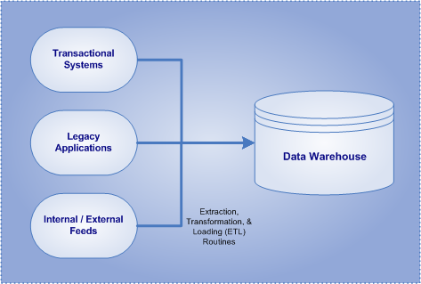

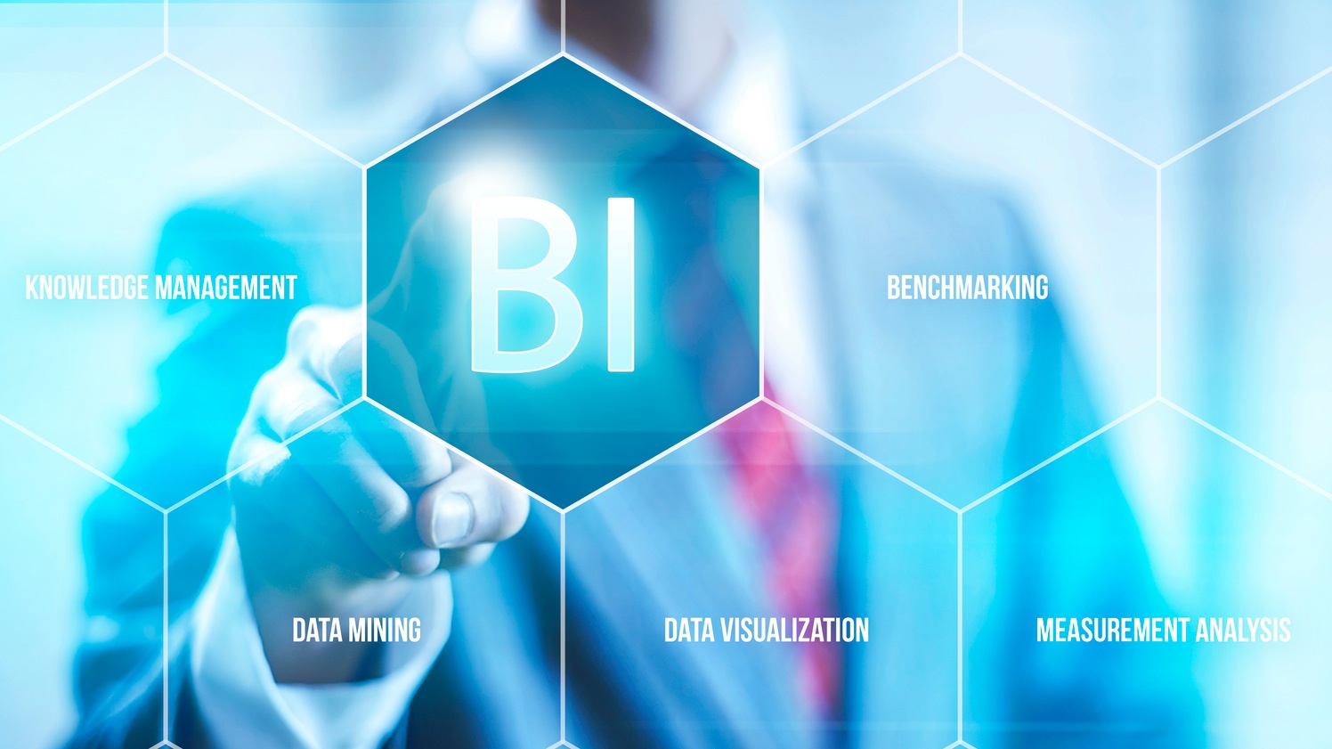



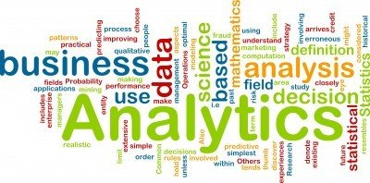

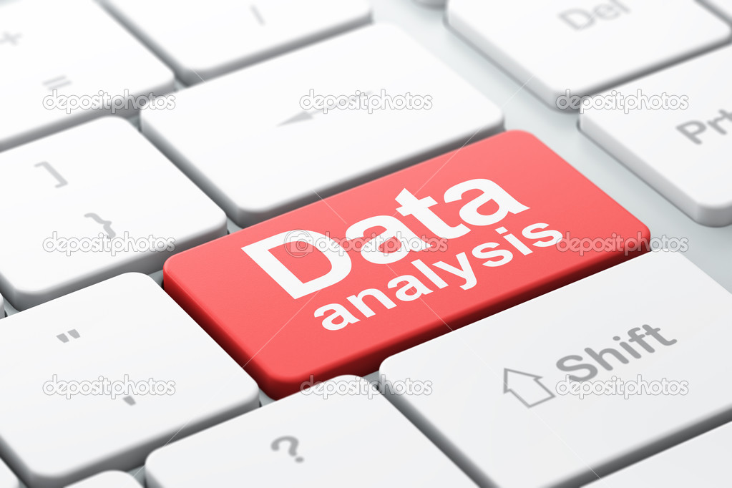





**Mobile:** +61-432226960 • **Email:** sree7525@gmail.com• **Australia Permanent Resident**



**Data Warehousing****• Business Intelligence**



**EXECUTIVE SUMMARY**

* **Certified BI professional** with **over 9 years** of IT experience including proven experience of 5+ years in analyzing, designing and implementing **Data Warehousing & Business Intelligence Solutions** usingvaried **BI tools.**
* Strong proficiency in full life cycle of BI solution development with outstanding capabilities in analysis, problem definition and requirements gathering. Knowledge of entire **SDLC life cycle** in the projects.
* Dedicated IT professional with expertise in configuration,development,design,testing and implementation of Business Intelligence applications/Data warehousing/OBIEE.
* Worked extensively in the analysis and development of **Data warehousing applications** using **OBIEE 11.1.1.6.2/OBIEE 10.1.4.x./Siebel Analytics 7.x.**
* Deft at designing, customizing & developing OBIEE/Siebel Analytics Repository(.rpd)-three layers (Physical layer, Business Model Mapping Layer and Presentation Layer and developing reports and dashboards for supporting the business analysis.
* Worked extensively on Oracle BI Administration Tool, Presentation Services, Answers & Interactive Dashboards and Security Implementation.
* Recognized for going beyond the role and consistently delivering under tight timelines for complex assignments.
* Experience in dealing with business stakeholders and clients.
* Successful in learning and comprehending new systems and methods with extremely good learning curve.
* Excellent analytical, communication & interpersonal skills and ability to perform independently and as a part of the team.

**CORE COMPETENCIES**

• Data warehousing **•** Business Intelligence & Visualization **•** Financial Performance Management **•** Business Analytics • Data Analysis **•** Team Management **•** Quality Management **•** Business Planning • Change Management



**KNOWLEDGE PURVIEW**

* Experience in diverse BI Tools such as **OBIEE, Siebel Analytics, OBIA**
* Experience in defining, interpreting and understanding technical requirements from end users, solution architects and technical vendors.
* Strong knowledge in Data warehousing concepts and exposure in OBIAPPs(OBIA)
* Ability to gather and understand business requirements and translate them into technical solutions using varied BI Tools.
* Strong skills in **requirement gathering, process mapping,design,documentation** and executing projects in time.
* Expertise in OLTP/OLAP system analysis and Knowledge on Dimensional Data modeling, Star Schema/Snowflake Schema, Fact and Dimension tables.
* Experience on wide range of databases like Oracle 10g/9i, DB2, MS SQL Server 2005/2000



**TECHNICAL EXPERTISE**

|  |  |
| --- | --- |
| **BI Tools** | Oracle Business Intelligence,OBIEE 11G,OBIEE 10G,OBIA |
| **ETL Tools** | Informatica, ODI |
| **Databases** | Oracle 8i, SQL-Server 2000 / 2005 |
| **Other Skills** | TIBCO Spotfire, **Tableau & Qlikview**. |



**CAREER HIGHLIGHTS**

* Actively led and collaborated with cross teams and handled successful project delivery thus received **‘Technology Ace Award’** .
* Delivered critical projects on time & bagged customer centric team award for 2 consecutive years.

**Experience**













* Achieved **" Best Performer"** award for my outstanding performance and excellent troubleshooting skills.
* Efficiently used Oracle Business Intelligence Suite for monitoring KPIs and automating various processes.
* Delivered end user Training and got accolades for it.



**CERTIFICATIONS**

* Oracle Business Intelligence Foundation Certified Implementation Specialist
* Oracle Certified Specialist



**ACADEMIC CREDENTIALS**

**MScTech. (Engineering Physics with Electronics & Instrumentation)**

Sri Venkateswara University,India **(University Gold Medalist)**



**Visa Status:** Australia 189 Subclass PR

**References:** Available upon request

***Project Details mentioned in the Annexure***

**ANNEXURE**

**PROJECTS UNDERTAKEN**

|  |  |
| --- | --- |
| **Company** | **Davidson Technologies, Australia** |
| **Client** | **State Trustees, Australia.** |
| **Role** | Reporting Analyst |
| **Duration** | Oct 2015 - Oct 2015 |
| **Environment** | OBIEE 11.1.1.6,ODI11.1.1.7g,Oracle 11g,OBIAPPS 11.1.1.7.1 |
|  |  |
| **Accountabilities** | * Analyzing the existing reports and propose the solution to the client * Analysis of the existing system to determine the data availability as per required reports.(Data Quality Checks ) * Involved in testing of existing reports and providing Technical Specifications * Analyzing the Requirements ,worked and delivered on the change requests given by clients. |

|  |  |
| --- | --- |
| **Project** | HSE Reporting |
| **Company** | **HCL Technologies,** |
| **Client** | **Weatherford, U.S.A** |
| **Role** | **Technical Lead/Release Coordinator** |
| **Duration** | Mar 2013– May 2015 |
| **Environment** | OBIEE 11.1.1.6.2, Informatica 9.1, SQL Server. |
| **Accountabilities** | * Supervised the development of data migration and transformation activities by other parties and ensuring they are developed to the appropriate technical standards . * Involved in developing the release strategy by working closely with team members from various teams and leading the data migration project . * Responsible for the efficient and effective implementation of the enterprise data warehouse stream. * Worked closely with scrum master, solution leads, test leads and developers to deliver the successful implementation of enterprise data warehouse streams. * Developed testing strategies for data migration and Involved in sanity testing of all dashboards and reports post deployment. * Involved in Technical planning for release deployments, reviewing test plans, supporting deployment/post deployment incidents. * Provided quality checks and ensured deliverables on time * Conducted daily stand ups for production issues and worked closely with stakeholders to communicate on incidents and outcomes. * Ensured cross-team communications for all key data related decisions and designs especially related to data. * Study of the source systems to determine the sources for various dimension and Fact Tables. * Data Analysis of the existing system to determine the data availability as per required reports.(Data Quality Checks) * Analyzing the Requirements ,worked and delivered on the change requests given by clients * Developing Metadata and Reports that can meet the end-user requirements and helps in decision and analysis. * Involved in the development of rpd and reports in Oracle Business Intelligence Enterprise edition (OBIEE) * Involved in admin activities like installation and moving the code from development to QA and Production environments. * Responsible for handling conflicting demands, prioritizing workloads and delegating effectively in order to deliver * Reviewed the deliverables and ensure that the deliverables meet clients requirements * Handled numerous enhancements and bug fixes for Environment Dashboards. * Responsible for all documentation needs identified during various stages of the project * Updating Technical and Functional documents with new changes made to the Dashboard. * Worked closely with Users, Developers and Administrators to resolve ongoing production problems by reviewing design changes made to production systems and made corresponding changes to OBIEE Repository * Involved in Testing of the reports to maintain the flow and relevancy of the solution. * Participated in various requirements, design and development meetings with the client for new report requests and multidimensional analysis cubes. * Led and technically mentored the team on dimensional report authoring techniques. * Coordinate project schedules and compile project status and provide updates to management & stakeholders. |

|  |  |
| --- | --- |
| **Project** | Finance Reporting |
| **Company** | **L&T InfoTech, India** |
| **Client** | **Balfour Beatty,U.K** |
| **Duration** | July'11– Mar'13 |
| **Environment** | OBIEE 10.1.3.4.1,OBI Apps 7.9.6.2 **,**Informatica 8.6, EBS 12.0, Oracle 10.0 |
| **Accountabilities** | * Effectively interacted with the end users for requirement gathering and defined requirement specifications document by access and retrieval of financial and personnel data from one single source. * Analysis of requirement, Impact of new requirement on existing application. * Created the OBI Apps technical Document (MD 70) according to Oracle process document. * Designed and tested many reports in the Dashboards for the Oracle Financial Analytics modules. * Created the Ad-hoc reports according to the client needs. * Extensive work on OBIEE reports for Finance Business Reports and custom Business Reports. * Modified the Subject areas for Financials. |

|  |  |
| --- | --- |
| **Company** | **Verizon Data Services, India** |
| **Client** | **Verizon Data Services,U.S.A** |
| **Role** | Tester |
| **Duration** | Nov '09 – Jan '11 |
| **Environment** | OBIEE 10.1.3.4.1,Siebel Analytics 7.8.4, Informatica 9.1, Oracle 9.0 |
|  |  |
| **Accountabilities** | * Reviewed the deliverables and ensure that the deliverables meet client’s requirements. * Involved in functional and performance testing of reports. * Creating test plans and test cases and executing test scripts * Used to understand IRs and validate the data for Retainco and Spinco databases |

|  |  |
| --- | --- |
| **Company** | **Tata Consultancy Services, India** |
| **Client** | **Nokia,Singapore** |
| **Role** | BI Developer/ Tester |
| **Duration** | Sep’07 – Nov’09 |
| **Environment** | Siebel Analytics 7.8.4, OBIEE 10.1.3.4.1, Informatica 9.1, Oracle 9.0 |
|  |  |
| **Accountabilities** | * Analyzed the mock-up’s requirement specification which contain the reports as desired by the client * Involved in extensive discussions with business users and developers to understand the business/requirements/functionality. * Developing and configuring OBIEE Repository(RPD),Interactive Dashboards, OBIEE Answers * Designed Schema/Diagrams using Fact, Dimensions, Physical, Alias and Logical tables. * Worked on both the development and in production support which includes building the code, maintain and modify the code as per business requirements. * Managed customer expectations to ensure strong customer satisfaction by meeting the business needs for IT systems in a timely manner * Made the team to handle numerous enhancements and bug fixes * Analyzing functional requirements, creating test scenarios & cases. * Creating test plans and test cases and executing test scripts * Reviewing the Test Scripts for all the Reports. |
| **Company** | **Hewlett Packard Global Soft, India** |
| **Client** | **Hewlett Packard Global Soft, U.S.A** |
| **Role** | Developer |
| **Duration** | Apr’06– Aug’07 |
| **Environment** | Vxworks 5.5, C++, Tornado 2.2, Windows |
|  |  |
| **Accountabilities** | * Involved in the development, testing of Development of Software Module for Exciter unit. * Involved in the lead activities and testing of the project * Involved in code reviews and implementation of review comments |

|  |  |
| --- | --- |
| **Company** | **Satyam Computer Services, India** |
| **Client** | **Motorola,U.S.A** |
| **Role** | Developer |
| **Duration** | Apr’05 – Apr’06 |
| **Environment** | Win CE, X 86 em |
|  |  |
| **Accountabilities** | * Analyzed the requirements and specifications to understand the Application * Designed and developed various utilities for the PC * Tested the desktop application. |